**A REPORT ON THE IMPACT OF YOUTUBE IN ENGLISH LANGUAGE LEARNING AMONG SELECT ELEMENTARY SCHOOL CHILDERN**

A field study submitted to

**GOVERNMENT ARTS AND SCIENCE COLLEGE, ARAKKONAM 631 051**

In partial fulfilment of the requirements for the degree of

**MASTER OF ARTS IN ENGLISH**

by

**J.GRACY**

REG. NO: 35621P02003

under the guidance of

**B. POOVILANGOTHAI., M.A., NET., SET,.**

Assistant Professor, PG Department of English



**PG DEPARTMENT OF ENGLISH**

**GOVERNMENT ARTS AND SCIENCE COLLEGE,**

**ARAKKONAM-631 051**

**JUNE-2022**

**FORM-A**

TITLE OF FIELD STUDY : A Report on the Impact of YouTube in

English Language Learning among Select

Elementary School Children

LANGUAGE : English

NAME OF THE CANDIDATE : J. Gracy

REG.NO : 35621P02003

AGE : 21

MALE/FEMALE : Female

DEPARTMENT : PG English

YEAR : MA., I.YEAR

SEMESTER : II

COLLEGE ADDRESS : Government Arts and Science

College, Attupakkam, Arakkonam

RESEARCH SUPREVISOR : B. POOVILANGOTHAI., M.A.,

NET., SET.

**DECLARATION**

I, **J. GRACY,** hereby declare that the field study entitled **A REPORT ON** **THE IMPACT OF YOUTUBE IN ENGLISH LANGUAGE LEARNING AMONG SELECT ELEMENTARY SCHOOL CHILDERN** is the result of my original and independent research work, carried out under the guidance of **Ms.** **B. POOVILANGOTHAI M.A., NET., SET.,** Assistant Professor, PG Department of English, Government Arts and Science College, Arakkonam and that has not been submitted for the award of any degree, diploma, or fellowship or any other similar titles of any university or institution previously.

Place: Arakkonam J.GRACY

Date:

( Reg.No:35621P02003)

**CERTIFICATE**

This is to certify that the Field Study entitled **A REPORT ON THE IMPACT OF YOUTUBE IN ENGLISH LANGUAGE LEARNING AMONG SELECT ELEMENTARY SCHOOL CHILDERN** is a bonafide work done by **J.GRACY, II M.A English,** Government Arts and Science College, Arakkonam, during the acadamic year 2021-2022. It is certified that this field study is an original work of the candidate carried out under my supervision.

Signature of Research supervisor Signature of HOD

**Ms. B. POOVILANGOTHAI M.A., NET, SET., Dr.P.SAMUEL.,M.A.,B,Ed.,M.Phil.,Ph.D**

Assistant Professor Assistant Professor & Head

PG Department of English PG Department of English

Govt. Arts and Science College Govt. Arts and Science College

Arakkonam-631 051 Arakkonam-631 051

| **S.NO** | **CONTENT** | **PAGE NO** |
| --- | --- | --- |
| **1.**  **2.**  **3.**  **4.**  **5.**  **6.**  **7.**  **8.**  **9.**  **10. 11.**  **12.** | Introduction  Aim of the study  Place of study  Preface of study  Field study tools  Statistical collection  Need and purpose of study  Field study work plan  Statistical analysis  Study result  Implementing the solution  Conclusion  Appendix I – questionnaire  Appendix II – photographs | 1  3  3  3  8  8  8  9  10  15  17  17  18  22 |

**A REPORT ON THE IMPACT OF YOUTUBE IN ENGLISH LANGUAGE LEARNING AMONG SELECT ELEMENTARY SCHOOL CHILDREN**

**INTRODUCTION**

English as a second language for children. The early exposure to a language means easy and natural acquisition of the language. This study aims to know the effects YouTube channels have in building English communication skill among the children. YouTube channels – particularly rhymes, stories, and cartoon channels – are quite popular among children and parents. Many parents use You Tube watching as a control mechanism. Most kids love to spend time watching You Tube channels as they are colourful and has catchy music. Normally young children below the age of five do not mind the language in which the channel is played. They enjoy the music and the ambience. Such channels could be used as educational tools especially in language learning.

You Tube was believed to be an effective medium that can improve young children’s communication skill. Children’s media is an important agent to impact children's growth and development. The internet is the digital media of the 21st century. YouTube has now become an infotainment source for children. The early study on the relationship between introducing English through a digital platform show a significant role in children. In the past media has always had a direct impact on children’s psychological, social, and cultural development. There was Parents and children to introduce and explain how to use information technology of open YouTube English cartoon and stories. When children open these sites they don’t need the assistance of their parents to choose stories, rhymes, and games.

While YouTube is user friendly, it also has a negative impact. Now many parents let their children play in the phone and watch video on YouTube, there is the danger of children becoming quiet and non-communicative. Parents calmly carry on their work without having any disturbance by the child. This is a big mistake. Children may not care about the environment. They may even become lazy to move. Children can access all videos freely on YouTube if there is no supervision by their parents.

Apart from this negative effect, You Tube could be used to the advantage and well rounded growth of children if there is proper guidance from parents. YouTube has a variety of channels that can be used to educate and entertain children , of course it will provide positive benefits for children. One of theme is the introduction and mastery of English language in fun way. Through YouTube, children will be able to master everything faster and get it registered in their memories. The lessons thus gained could be applied in their everyday life unintentionally. A word or sentence that a child first watched would be remembered and would be spoken from thechild's memory**.** Along with the increasing ability of children to explore the environment, because of the increased magnitude of coordination and motor control accompanied by increased ability to ask questions using words that can be understood by others. Most of the students lackEnglish vocabulary which hinters them from reading, writing and communicating with others by using English vocabulary. You tube on improving the vocabulary learning process of fifth grade students. Using games for students as helping tool in teaching and learning can make them learn English in the way children learn their mother tongue without being threatened by the learning process itself.

**AIM OF THE STUDY**

The study aims at identifying the importance of using technology especially in YouTube for the developing of English vocabulary among elementary school children. Further, the current study aims at identify children level of ability through the use of technology and modern methods used in education, specifically the use of YouTube. The use of YouTube increased the ability of children in learning new vocabulary which show that technology has positive effects on learning process.

**PREFACE TO THE STUDY**

In this study, investigator analyse the importance of English and how the children learn and improve English language skills through the help of YouTube.

**PLACE OF STUDY**

Elementary School children Field study period 15 children aged between 6-8 who were fluent in spoken English have selected for the study. Many of them are form rural, Tamil medium government school background and few of them had urban private English medium school background. All of these children spend a lot of time watching YouTube in many languages the children were contacts through their parents.

**SAMPLE**

A.Adheesh

* English Medium
* 3rd Standard
* Royal Metric Higher Secondary School in Thakkolam
* Cheyyur
* His father occupation was MLF Assistant Manager
* He is 7 Years Old
* He is not try to learn English in YouTube but he learn unexpectedly

R. Mukithra

* English Medium
* 3rd Standard
* Selvam Metric Higher Secondary School in Arakkonam
* Cheyyur
* Her Mother occupation was Teacher
* She is 7 Years Old
* Her teachers encourages to learn English

M. Swetha

* English Medium
* 3rd Standard
* Vimal primary School in Arakkonam
* Cheyyur
* Her father occupation was MLF Supervisor
* She is 7 Years Old
* Teachers motivates her to learn English

G.J. Oviya

* English Medium
* 3rd Standard
* Goodearth Metric Higher Secondary School in Natverapatu
* Thambaram
* Her father occupation was Cevil Enginner
* She is 7 Years Old
* Parents encourage her to learn English

N.Sukumaran

* Tamil Medium
* 4th standard
* CSI Primary school in Mosur
* Cheyyur
* Her Mother occupation was Tailer
* He is 8Years Old
* Teachers Motivates her to learn English

S. Inbanathan

* Tamil Medium
* 4th Standard
* CSI Primary School in Mosur
* Cheyyur
* His father occupation was Auto driver
* He is 8 Years Old
* Teachers Encouraged to learn in English

D. Kaviya

* English Medium
* 2nd Standard
* CSI Primary school in Mosur
* Cheyyur
* Her father occupation was Electrician
* She is 7 Years Old
* Teachers Encourage to learn in English

R.H. Pooja Sri

* English Medium
* 2nd Standard
* Donbasco Metriculation Higher Secondary School in perambur
* Thiruvannamalai
* Her father occupation was cevil engineer
* She is 7 Years Old
* Parents Motivate to Learn in English

A. Harish

* English Medium
* 5th Standard
* Royal Metric Higher Secondary School in Thakkolam
* Cheyyur
* He Father occupation was MLF Assistant Manager
* He is 8 Years Old
* Her teacher encourages to learn in English

B.Jeslin

* English Medium
* 3rd Standard
* Krishna Primary School in Arakkonam
* Cheyyur
* Her father occupation was Bus driver
* She is 7 Years Old
* Parents encourages to learn in English

M.Sruthi

* English Medium
* 3rd Standard
* Royal Metric higher Secondary School in Thakkolam
* Cheyyur
* Her father occupation was MLF Supervisor
* She is 7 Years Old
* Her teachers encoured to learn English

C.Rubesh

* English Medium
* 5th Standard
* Rajam primary School in Mosur
* Cheyyur
* Her father occupation was painter
* He is 7 Years Old
* Teachers Encouraged to learn in English

P. Jaya shree

* Tamil Medium
* 4th Standard
* CSI Primary school in Mosur
* Cheyyur
* Her father occupation was cooli
* She is 7 Years Old
* Teacher engcourages to learn in English

S.Sadhana

* English Medium
* 3rd Standard
* Vivekananda Metric higher Secondary school in kavanoor
* Arakkonam
* Her father occupation was Teacher
* She is 7 Years Old
* Her Teachers encourages to learn in English

R. Ramya shree

* Tamil Medium
* 3rd Standard
* CSI primary School in Mosur
* Cheyyur
* Her father occupation was cooli
* She is 7 Years
* Her Teachers Encourages to learn in English

**FIELD STUDY TOOLS**

Questionnaire was used to collect data to learn the impact of You Tube in English Language Learning. The children were first befriended to make them talk comfortably. Most of the questions were answered in a friendly interview.

**STATISTICAL COLLECTION**

The investigator took 15 children for her field study. The questionnaire was served and responses were recorded and collected. In this survey, the investigator investing the knowledge knowledge level and social impact on children.

**NEED AND PURPOSE OF THE STUDY**

The purpose study discussed children to learn English form watching YouTube videos Children are monitored their learning progress form you tube videos. Studied their pronunciation and body language improvement

Analysis importance of technologies in learning process read visual teaching impact of their learning process.

You Tube was seen by all the children’s in the world in different language and they learned everything in YouTube.

**FIELD STUDY WORK PLAN**

Selection of site for study

Selecting the tool for study

Preparing list of questionnaire for statistics collection

Statistical collection

Statistical analysis

Knowing the details of problem from the results

Consulting and deciding on a solution

Solution implementation

**SATISTICAL ANALYSIS**

Interviewing elementary school children through questionnaires, The study was also concluded through the study we learned about the impact on children learning English in YouTube.

The children was Songs are among the most enjoyable and effective ways to learn a new language, Their melodies and rhymes help to create strong memories, Vital for picking up new verbs, expression and colloquialisms.

Children who are learning in English second language can benefit from listening and singing along to nursery rhymes (traditional children songs ) as they help to improve memory and recall skill.

**FINDING**

**Pie chart: 1. Help received by a child in English language acquisition**

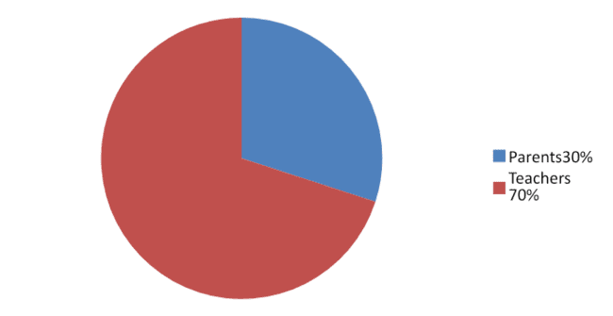

Learners usvally find it easier to understand writing English than spoken english. So along to a YouTube lesson can be very helpful. In this pie chart 30% of children are learn english in YouTube with the help of their parents and 70% are learn by teachers.

**Pie chart: 2. The social media platform children are familiar with**

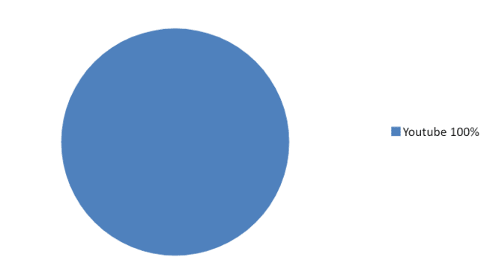

This chart explains that All the children (100%) use YouTube.

**Pie chart: 3 Most watched YouTube channels**

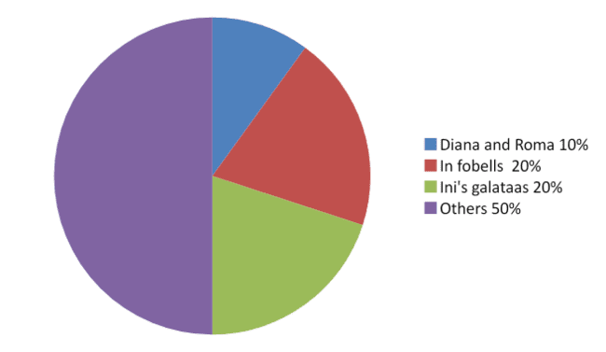

Among 15, 20% children are watched infobells, 20% watched Ini’s galataas, 10% watched Diana and Roma and 50% watched other channels like ninja hattori, papa pig, vlad and nikita, Tom and jerry

**Pie chart:4. Knowledge acquired from YouTube**

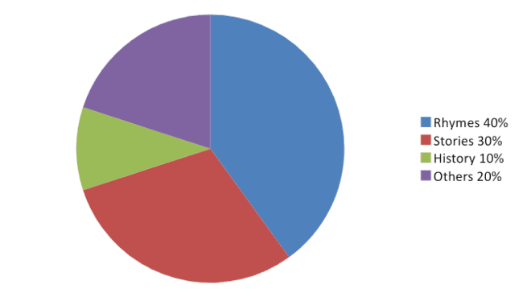

Among 15, 40% children are acquired knowledge from watching rhymes in YouTube, 30% acquired knowledge from watching stories and 10% watching history stories and 20 % were watch others like Ramayana and Mahabharata

**Pie chart: 5.Language in which YouTube is watched**

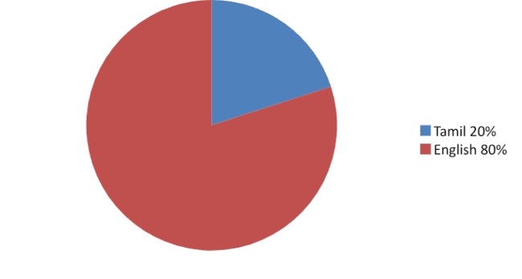

This pie chart explains that 20% children were watched YouTube in Tamil language and 80% children were watched YouTube in English language.

**Pie chart: 6. The number of hours spent in watching YouTube in a day by children**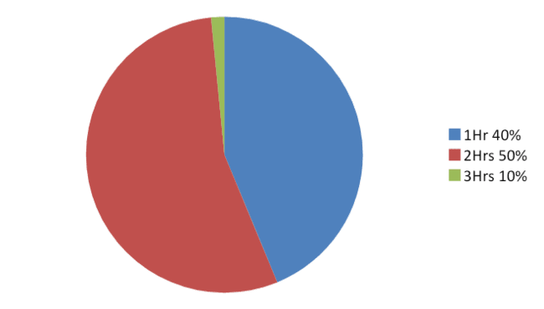

This pie chart explains that 50% of children were watched YouTube 1 hour and 40% of children were watched YouTube 2 hours and 10% of children watched YouTube 3 hours.

**STUDY RESULT**

Total number of Children : 15

No. of boys : 05

No. of girls : 10

1. Name of the children have been collected.
2. The investigator asked the board of education? In response out of 15 children, 4 children have studied in Government School in English Medium 3children have studied in Government School in Tamil Medium and 8 children are studying in Private School
3. The investigator asked how many languages they could speak? In response to that out of 15 children, The interviewed two children could speak one language in tamil 11 children told me they only speak 2 language Tamil and English 1 child told me they only speak 3 language Tamil English and Telgu they 1 child speak to More than three language Tamil English and Telgu
4. The investigator asked which language do you like to speak mostly? in the response to that out of 15 children, 14children said I likeEnglish 1 child said I like Tamil
5. The investigator asked Who helps you to speak English? In response to that out of 15 children, 3 the children told me that my parents help me speak to English 12 children told me that their teachers help than to read and speak English
6. The investigator asked which of the following social media platforms you familiar with are. In the response to that all the 15 children, 15 children said that they watching toYouTube
7. The investigator asked which of the following channels you watch in YouTube? In response to that out of 15 children, 3 children said they watching Diana and Roma 3 children watch to Infobells 3 children watch to In’s galataas 2 children watch to Vlad and Nikita 1 child watch in Ninja Hattori 1 child watch in Cooking channels 1 child watch in Peppa pig 1 children watch in Tom and Jerry
8. The investigator asked what did they learn from YouTube? In response to that out of 15 children, 9 children said they use YouTube to learn Rhymes 6 children said they use YouTube to learn Stories
9. The investigator asked In which language they watch YouTube In response to that out of 15 children, 15 The children said They would only watch English videos on YouTube
10. The investigator asked how many hours they spend in watch YouTube In a day? In response to that out of 15 children, 6 children told me they watch YouTube for on One horus 7 children told me they watch for 2hrs 2 children told me they watch YouTube for More than three horus
11. The investigator asked who do you speak English with? In response to that out of 15 children, 9 children said they would only speak English to my Parents 5 children said they would only speak English to my Teachers 1 child only told speak English with their Friends
12. The investigator asked what are the programs do you watch in YouTube? In response to that out of 15 children, 3children told me that the would watch Chotta Bheem 3 children told me the would watch Tom and Jerry 2 children told me the would watch Shin Chan 3 children told me the would watch Mr Bheem 3chlidren told me the would watch Doreman 1child told me the would watch Mottu Pathulu

**IMPLEMENTING THE SOLUTION**

Modern learning media such as YouTube currently in fluency children’s to develop special knowledge.

YouTube is increasing demand in education for learning English vocabulary.

The activity of watching a video such as simple English to remember their vocabulary and sentence. YouTube can stimulate children to learning style ability. With these activities, English vocabulary can be sent to long term memory as a language.

The Chidren also able to speak English through some YouTube channel gives more help for the children.

**CONCLUSION**

Final analysis of finding focus on content analysis keeping in mind the use of YouTube kid’s channels in developing young children’s communication skills in English. During the Elementary-school years, children acquire the language and communication skills necessary to express their needs, thought, and feelings in social interaction, and they learn to respond appropriately to others. Through effective communication, they also learn to be socially competent individuals, building respectful, positive interactions and relationships with others this all eges children to learn about themselves, others, and the world. These studies have never seen YouTube kid’s media channels that can design early communication skills for young children. Watching a short English rhymes and sing simple English songs on YouTube are using to help learners 5-8 years old master English language

**APPENDIX**-**I**

**QUESTIONNAIRE**

**THE IMPACT OF YOUTUBE IN ENGLISH LANGUAGE LEARNING AMONG SELECT ELEMENTARY SCHOOL CHILDREN**

1. Name :

2. Date of Birth :

3. Age :

4. Gender :

5. Phone No& Mail ID : Nil 6. Standard :

7. Board of education? a) State board b) Government Tamil/English c) Private d) ICSE

8. How many languages can you speak? a) 1 b) 2 c) 3 d) More than three 9.Which language do you like to speak mostly? a) English b) Tamil c) Hindi d) Others 10. Who helps you to speak English? a)Parents b)Friends c) Teachers d) YouTube 11. Which of the following social media platform are you familiar with? a) YouTube b) Face book c) Instagram d) Others

12. Which of the following channels do you watch in YouTube? a) Diana and Roma b) Info bells c) Ini’s galataas d) Others 13. What do you learn from YouTube? a) Rhymes b) Stories c) History d) Others 14.In which language do you watch YouTube? a) Tamil b) English c) Hindi d)Others 15.How many hours do you watch YouTube in a day?

a) 1 hr

b) 2 hrs

c) 3 hrs d) More than 3 hrs

16. Who do you speak English with? a) Parents b) Teachers c) Friends d) Others 17. What are the programs do you watch in YouTube? a) Chotta Bheem b) Tom& jerry c) Shin Chan d) Others

**APENDIX – II**

**PHOTOGRAPHS**